# Rest and Motion

**Motion**

* If the position of an object does not change as time passes, then it is said to be at **rest**. If the position of an object changes as time passes, then it is said to be in **motion**.
* An object can be at rest with respect to one thing and in motion with respect to some other thing at the same time. So, the states of **rest and motion are relative** only.
* To locate the position of an object, we have to choose some suitable **reference point** called the

**origin**.

# Distance and Displacement

* The **distance** travelled by an object is the length of the actual path traversed by the object during motion. It is a **scalar** quantity.
* The **displacement** of an object in motion is the shortest distance between the initial position and the final position of the object. It is a **vector** quantity.

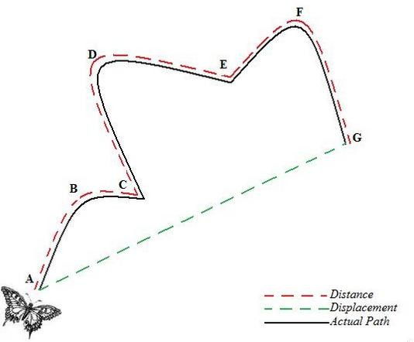

* The distance travelled by an object in motion can never be zero or negative.
* The displacement of an object can be positive, zero or negative. Never can the distance travelled be less than the displacement.
* Both distance and displacement have the same units.

# Uniform and Non-uniform Motion



Uniform motion

Motion

Non-uniform motion

* An object is said to be in **uniform motion** if it travels equal distances in equal intervals of time, howsoever small the intervals may be.
* An object is said to have **non-uniform motion** if it travels unequal distances in equal intervals of time.

# Speed

* **Speed** of a body is defined as the distance travelled by the body in unit time. The SI unit of speed is

**metre/second** (m/s).

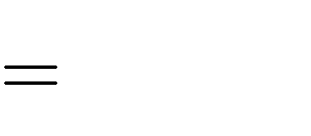

Distance travelled

Time taken

Speed

* If ‘s’ is the distance travelled by a body in time ‘t’, then its speed ‘v’ is given as v

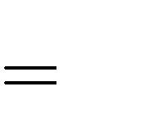

s

t

* Speed of a body is a **scalar** quantity. It can be zero or positive but can never be negative.
* If a body covers equal distances in equal time intervals, howsoever small the intervals may be, then it is said to have **uniform speed** (or **constant speed**).
* If a body covers unequal distances in equal time intervals, however small the intervals may be, then it is said to have **non-uniform speed** (or **variable speed**).
* For bodies moving with non-uniform speed, we describe the rate of motion in terms of their **average speed**.

Average speed= Total distance travelled

Total time taken

# Velocity

* **Velocity** of a body is defined as the distance travelled by the body in unit time in a given direction.
* The SI unit of velocity is the same as that of speed, i.e. metre/second (m/s).

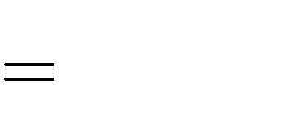

Distance travelled in a given direction

Time taken

Velocity

or, Velocity



Displacement

Time taken

i.e.

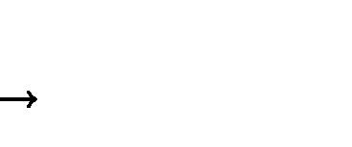

v s

t

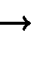where v is velocity and s is displacement of the body in time t.

* Velocity of a body is a **vector** quantity. It can be positive, negative or zero.
* A body is said to be moving with **uniform velocity** (or **constant velocity**) if it travels along a straight line, covering equal distances in equal intervals of time, howsoever small these intervals may be.
* A body is said to be moving with **non-uniform velocity** (or **variable velocity**) if it covers unequal distances in a particular direction in equal intervals of time or if the direction of motion of the body changes.
* When the velocity of a body is changing at a uniform rate over a period of time, the **average velocity**

for that time period is given by the arithmetic mean of the initial and final velocity of the body.

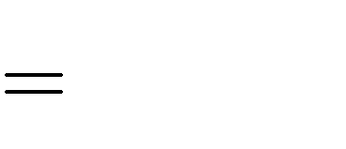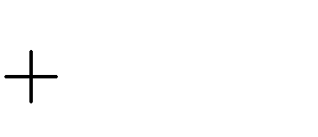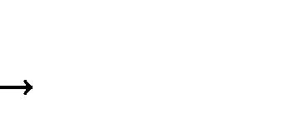

Average velocity

Initial velocity + Final velocity 2

or vav u v 2

where ‘u’ is initial velocity, ‘v’ is final velocity and is average velocity.

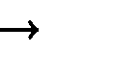

vav

# Acceleration

* **Acceleration** of a body is defined as the rate of change of its velocity with time.

Acceleration

or, a



v - u

t

Change in velocity Time taken

Final velocity - Initial velocity



Time taken

where ‘u’ is initial velocity, ‘v’ is final velocity, ‘a’ is acceleration of the body and ‘t’ is time taken for change in velocity.

* Acceleration is a **vector** quantity. It can be positive, negative or zero. The SI unit of acceleration is metre per second square (m/s2).
* If the velocity of a body increases, then the acceleration is positive. If the velocity of a body decreases, then the acceleration is negative. **Negative acceleration** is called **retardation**.
* If acceleration occurs in the direction of velocity, then it is taken as positive and negative when it is opposite to the direction of velocity.
* A body is said to possess **uniform acceleration** if it travels in a straight line and its velocity increases or decreases by equal amounts in equal intervals of time.
* A body is said to possess **non-uniform acceleration** if its velocity changes by unequal amounts in equal intervals of time.

# Distance–Time Graph

* The distance–time graph of **a body moving with uniform speed** is a straight line.

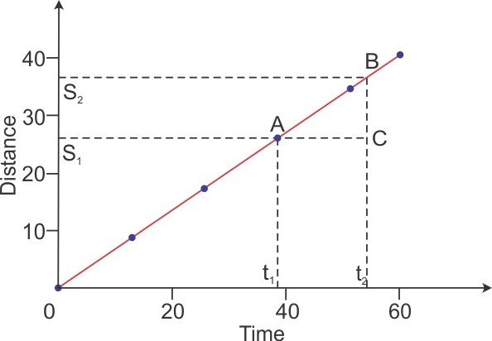

* **Speed** of a body can be obtained from the **slope of the distance–time graph**.
* Let s1 and s2 be the distance travelled by the object in time t1 and t2, respectively. Here (s2 – s1) gives the distance travelled by the body in time interval (t2 – t1).



Distance travelled

Time taken

Speed

v

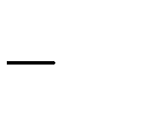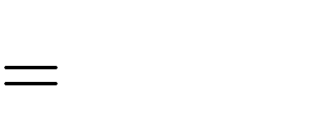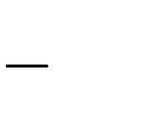

s2 s1

t2 t1

* The distance–time graph of **a body moving with non-uniform speed** is a curved line with a variable slope indicating variable speed.

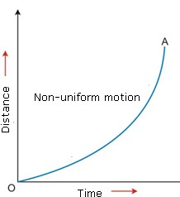

# Velocity–Time Graph

* 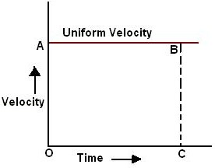The velocity–time graph of **a body moving with uniform velocity** is a straight line parallel to the time axis.
* The magnitude of **displacement** or **distance** travelled by the body is equal to the **area enclosed by the velocity–time graph and time axis.**

Distance travelled = Speed × Time taken

= OA × OC

= Area of rectangle OABC

* The velocity–time graph of **a body moving with uniform acceleration** is a straight line inclined to the time axis.

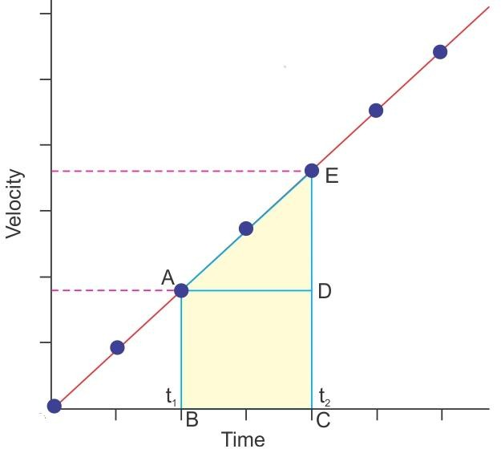

* + The **slope of the velocity–time graph** represents the **acceleration** of the body.

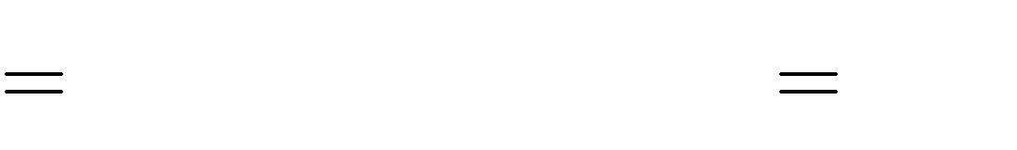

Change in speed ED

Time taken AD

Acceleration

* + The **area enclosed by the velocity–time graph and time axis** gives the **distance** travelled by the body.

Distance travelled = Area of ABCDE

= Area of triangle ADE+ Area of rectangle ABCD



1 AD DE + AB BC 2

=

* The velocity–time graph of **a body moving with non-uniform acceleration** can have any shape, indicating variable speed.

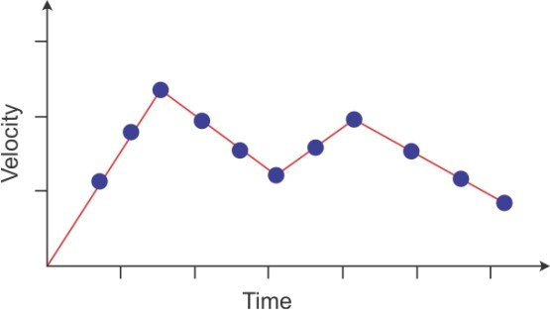

# Equations of Motion

* The three equations of motion of a body moving along a straight line with **uniform acceleration are**



v = u + at

s = ut + (1/2) at2

v2 - u2 = 2as

where ‘**u’ is initial velocity** of the body which moves **with uniform acceleration ‘a’** for time t, ‘**v’ is final velocity** and ‘**s’ is distance** travelled by the body in time t.

# Uniform Circular Motion

* When a body moves along a circular path with a uniform speed, its motion is called **uniform circular motion.**
* Examples: Motion of the Moon around the Earth, a cyclist moving in a circular track at constant speed
* In uniform circular motion, although the speed remains constant, the direction of motion and velocity change continuously. Thus, uniform circular motion is an **accelerated motion**.
* The external force needed to make a body travel in a circular path is known as **centripetal force**.
* The circumference of a circle of radius ‘r’ is given by 2r. If a body takes ‘t’ seconds to go once round

the circular path of radius ‘r’, then its velocity ‘v’ is given by v  2πr .

t